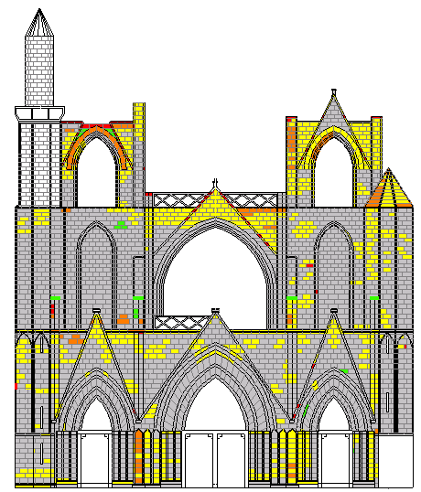
No visible weathering
Slightly weathered
Moderately weathered
Highly weathered
Extremely weathered (total failure)

Figure 6.5 Weathering grade assessment of stone on the western façade
(Drawing and mapping by Y.M. Ibreighith)
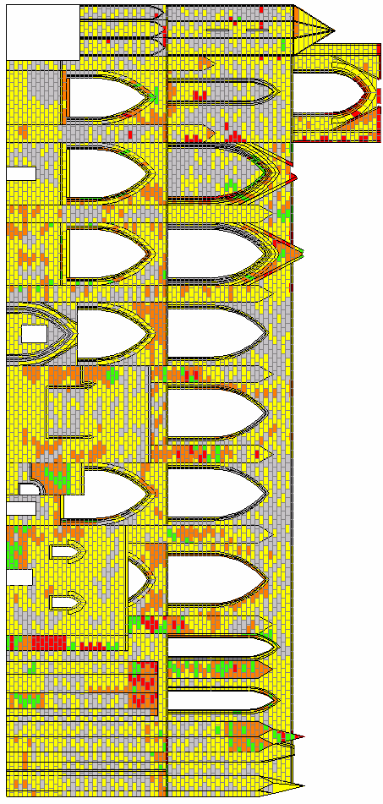
Figure 6.6 Weathering grade assessment of stone on the southern façade
(Drawing and mapping by Y.M. Ibreighith)
No visible weathering
Slightly weathered
Moderately weathered
Highly weathered
Extremely weathered (total failure)

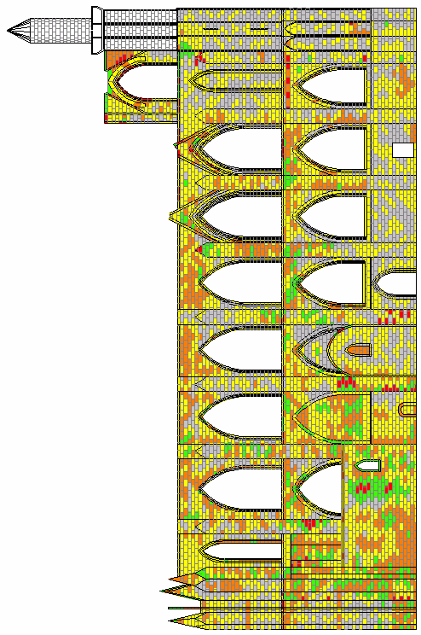
No visible weathering
Slightly weathered
Moderately weathered
Highly weathered
Extremely weathered (total failure)

Figure 6.7 Weathering grade assessment of stone on the northern façade
(Drawing and mapping by Y.M. Ibreighith)

No visible weathering
Slightly weathered
Moderately weathered
Highly weathered
Extremely weathered (total failure)

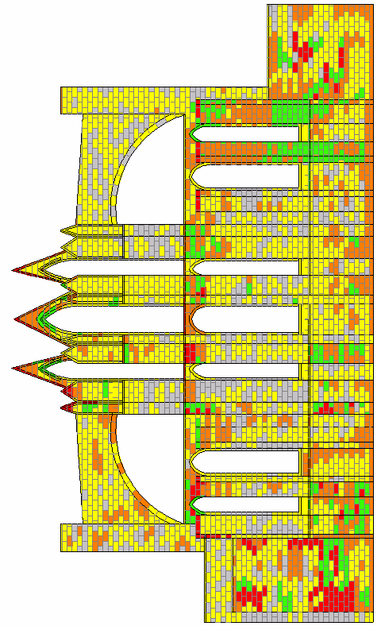

Figure 6.8 Weathering grade assessment of stone on the eastern façade
(Drawing and mapping by Y.M. Ibreighith)

No visible weathering
Slightly weathered
Moderately weathered
Highly weathered
Extremely weathered (total failure)

